
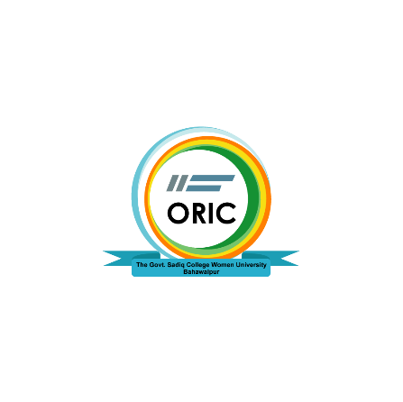

Department Research and Innovation Performance Award Form
The Govt. Sadiq College Women University, Bahawalpur
Office of Research Innovation and Commercialization (ORIC)
Email: oric@gscwu.edu.pk

Form ORIC-GSCWU-01B
Instructions:
- Please only type in the gray area by clicking the cursor there.
- Try to write precisely.
- The faculty member being nominated for Faculty Friday must follow the downward hierarchy (Dean, HOD, Professor, etc.)
- An individual must have a high research profile (No. of Research papers/Grants).
- The faculty member with a vibrant personality (to be a role model for others with respect to a personal and professional trait) can be featured
- Hard copy/handwritten forms will not be entertained.
- After completion, convert the form into PDF for onward transmission.
- Share it from the head’s official email account to ORIC at oric@gscwu.edu.pk

1. | Name:

2. | Designation:

3. | Department:

4. | Qualification:

5. | Facebook ID:

6. | Contact No. :

7. | Experience in University:

8. | No. of Research Papers:

9. | Competitive & Funded Research Activity:

10. | Joint Research & Networked Funded Activity:

11. | Policy Case Study:

12. | Linkages Networking Output:

13. | MoUs (Signed/Logged):

14. | Contract Research,Consultancies & Innovation (IP/Equivalence):

____________________________________________________________________________
For Office Use of ORIC-UOS Only

____________ ______________
Director ORIC Vice Chancellor

