
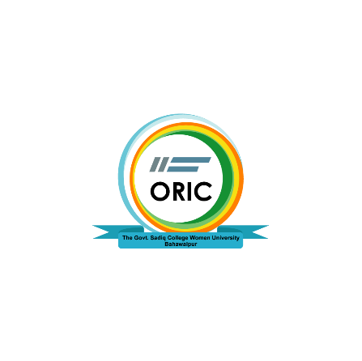

The Govt. Sadiq College Women University, Bahawalpur
Office of Research Innovation and Commercialization (ORIC)
Email: oric@gscwu.edu.pk

Form ORIC-GSCWU-19
Standard Operation Practice for Provision of Travel Grant
Instructions:
- Please only type in the gray area by clicking the cursor there
- Try to write precisely
- Hard copy/handwritten forms will not be entertained
- After completion, convert the form into PDF for onward transmission
- Share the form with ORIC for official work
- Travel grant requests shall be approved as in reimbursement mode only. No advance payment shall be made.
- International travel grant requests shall only be considered where the requestee is to present his/her paper in a Scopus-covered conference.
- Share it at oric@gscwu.edu.pk

Standard Operation Practice for Provision of Travel Grant
Responsible Position: Manager Innovation and Commercialization
Monitoring by: Deputy Director ORIC
- Submission of the application form available for Travel Grant at the HR office to the Director ORIC
- Verification of details
- Approval by the authorities as per the following thresholds.
- Director ORIC may approve local travel grant requests worth up to PKR 50,000/-
- The Vice Chancellor Office will approve all international travel grant requests; and national travel grant requests worth more than PKR 50,000/-
- Reimbursement of the incurred registration + travel charges.

For ORIC-GSCWU use only

Remarks if any;

____________

Director ORIC Dated: _________________

